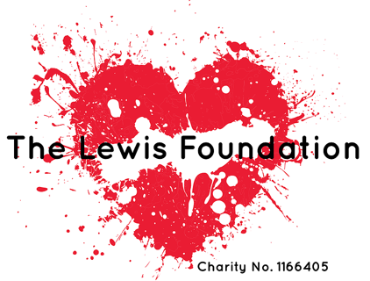
I AM JOINING TEAM LEWIS – SPONSOR ME!

Please sponsor me (name of participant)

To (name of event)

In aid of The Lewis Foundation

If I have ticked the box headed ‘Gift Aid? √’, I confirm that I am a UK Income or Capital Gains taxpayer. I have read this statement and want the charity or Community Amateur Sports Club (CASC) named above to reclaim tax on the donation detailed below, given on the date shown. I understand that if I pay less Income Tax / or Capital Gains tax in the current tax year than the amount of Gift Aid claimed on all of my donations it is my responsibility to pay any difference. I understand the charity will reclaim 25p of tax on every £1 that I have given.

Remember: You must provide your full name, home address, postcode & ‘✓’ Gift Aid for the charity or CASC to claim tax back on your donation.

 | Sponsor’s Full Name  (First name & surname) | Sponsor’s Home address  Only needed if are Gift Aiding your donation.  Don’t give your work address if you are Gift Aiding your donation. | Postcode | Donation Amount  £ | Date paid | Gift Aid?  ‘✓’
1
2
3
4
5
6
7
8
9
10
11
12
13
14
15
16
17
18
19
20
21
22
 |  | Total donations | £
 |  | Date donations given to The Lewis Foundation

