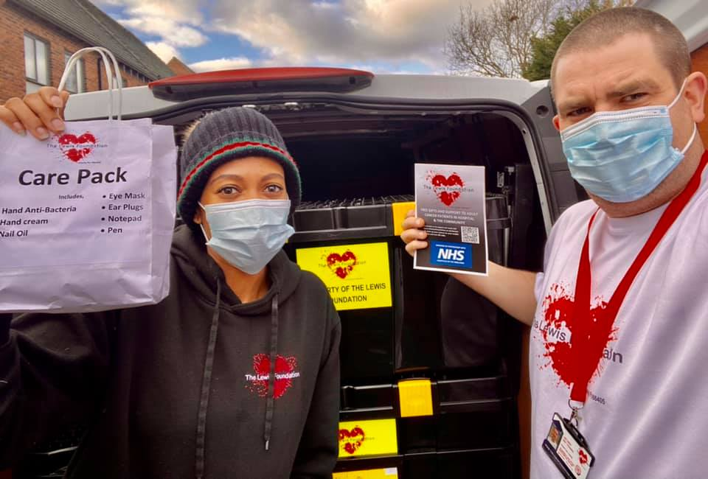

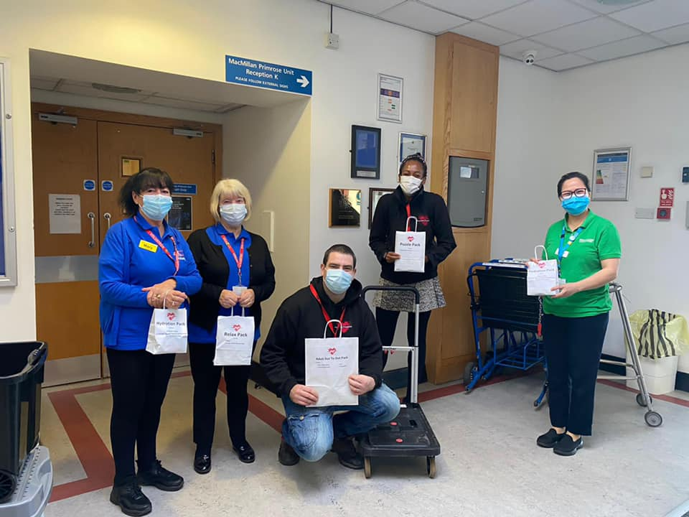

**To donate or to support our work visit www.thelewisfoundation.co.uk/donate or open your camera on your mobile phone & scan QR code**

**We provide a free gift pack to adults receiving treatment for Cancer in hospital. This is so they have something nice to look forward to whilst in hospital. This could be a puzzle pack, care pack, adult colouring books pack etc. Whilst those items may not at face value seem important when you are on the ward they become important.**

FREE GIFT PACK FOR CANCER PATIENTS

**WWW.THELEWISFOUNDATION.CO.UK**

**The lewis foundation**

**thelewisfoundation**

**@uk_tlf**

**The Lewis Foundation**